Marquies White

CIS129

12/18/2024

Final Project Documentation & Research Notes

***Step 1. Research and Problem Selection***

**Identify a problem**

I am a Learning & Development Coordinator at a non-profit organization. Some adult learners in the workplace struggle with engaging with online learning platforms in a meaningful way. This is due to a combination of factors, and my initial assumption and observation is that one of the main factors is due to a lack of proper time management. This can be caused by the self-paced nature of online learning.

In an adult learning case study by Karlsen et al. (2023), several participants of the study said that a lack of time and competing priorities caused them to not take full advantage of their online learning (specifically microlearnings in this study). Participants also noted that it was difficult to create a habit of online learning due to other pressing tasks such as meetings. While the flexibility of online learning can be beneficial, I believe that adult learners need some help in order to set aside time for their online learning.

**Explore Existing Solutions**

In the study by Karlsen et al. (2023), the only consistent way that participants said that they completed their online learnings is when it is mandated by their superiors. This is not a true solution, as adult learners should not have to be required to complete online learning for their own development.

In another online learning study, Sahin and Yurdugül (2022) shared that participants of their study said that reminders and notifications were helpful to get them to use the online learning platform. I believe that this is a step in the right direction and similar to how I would approach solving the problem using programming.

**Justify Your Choice**

This problem interests me because my current role is heavily focused on adult learners and I can see the issues that adult learners have with online learning platforms. In the post-COVID world where remote and hybrid work are still more prevalent than ever before, online learning is not going away. When used correctly, online learning can be an invaluable tool to develop staff at any organization. This is why I think it is important to find a way to build healthy online learning habits.

***Step 2. Design a Solution***

**Propose a Software Solution**

My program solution is to create a program that would prompt users to schedule a time when they would like to complete their online learning after they have enrolled in an online course. After scheduling a time, that time would automatically send a calendar invite to the user and block that time off in their calendar. That calendar block would discourage the adult learner from scheduling any meetings or other tasks during that time. It also could assist them with planning tasks around that scheduled time and keep adequate time for learning.

The online learning platform that my organization currently uses has a similar feature for when an adult learner enrolls in a live session that is not self-paced. When a user enrolls in a live course (in-person or virtual) a calendar invite is automatically sent to the user with the details. I would like to utilize this approach with self-paced courses as well, but give the user the flexibility to schedule their own time. Prompting the user to schedule time as soon as they enroll may get the user to "buy-in" on the online course.

**Pseudocode**

(Code starts after the user enrolls in a course)

Start program

Course name is collected from online learning platform

Course description is collected from online learning platform

Estimated completion time is collected from online learning platform

Print "Course Scheduler"

Print "Please schedule a date and time to complete your course here. The time and date you schedule will automatically be booked on your calendar."

Input "Your email."

If Input is invalid

Print "Invalid input. Please enter a valid email."

Repeat Input "Your email."

Input "Date (MM\DD\YYYY)"

If Input is invalid

Print "Invalid input. Please enter a date in MM/DD/YYYY."

Repeat Input "Date (MM\DD\YYYY)"

Input "Time (HH:MM)"

Print "*Your calendar's default time zone will be used."

If Input is invalid

Print "Invalid input. Please enter time as HH:MM."

Input "How long would you like to book on your calendar for the training? The estimated completion time is [estimated completion time pulled from online learning platform] minutes."

If Input is invalid

Print "Invalid input. Please enter a valid duration in minutes."

Repeat Input "How long would you like to book on your calendar for the training? The estimated completion time is [estimated completion time pulled from online learning platform] minutes."

Button "I do not want a calendar invite."

If user clicks Button, Input "Are you sure you do not want a calendar invite? (Y/N)"

If "Y", end program

If "N", uncheck Button

Button "Submit."

If user clicks Button, print "Your calendar invite has been sent. Thank you."

If user clicks Button and Time and Date are invalid, "Please complete all required fields to schedule."

Send course details gathered by online learning platform and user entered details to user's email calendar

End program

**User Interaction**

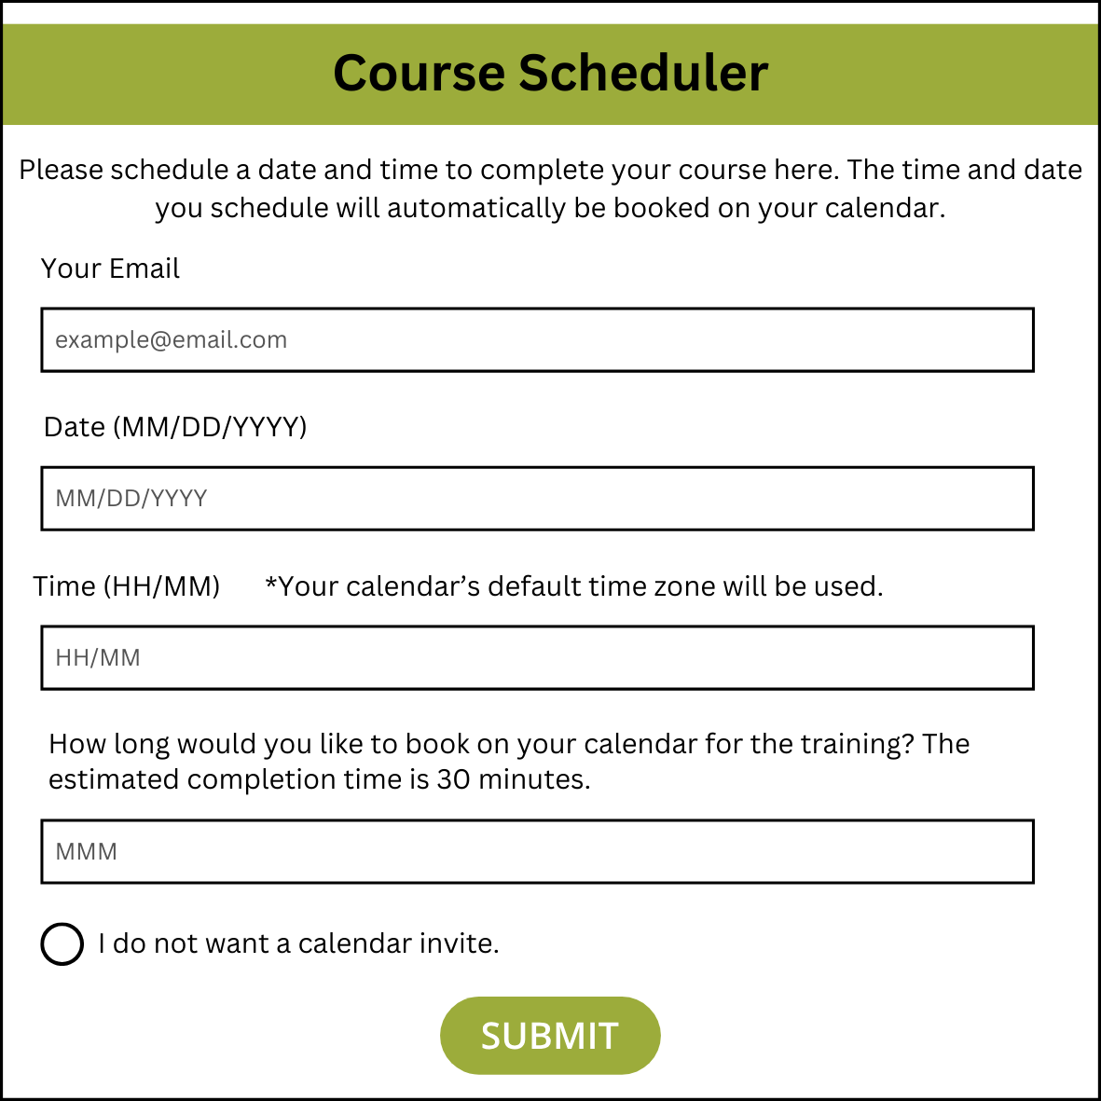

**Works Cited**

Karlsen, J. T., Balsvik, E., & Rønnevik, M. (2023). A study of employees’ utilization of microlearning platforms in organizations. The Learning Organization, 30(6), 760-776. doi:<https://doi.org/10.1108/TLO-07-2022-0080>

Şahin Muhittin, & Yurdugül Halil. (2022). Learners’ needs in online learning environments and third generation learning management systems (LMS 3.0). Technology, Knowledge and Learning, 27(1), 33-48. doi:<https://doi.org/10.1007/s10758-020-09479-x>